Inventory Management System

All these types of software automatic configure inside operating system after installation it having Java, MYSQL, Apache and operating system base configuration file, it doesn’t need to configure manually.
Introduction
The Inventory Management System is a product management tool through which you can track your goods and services. It keeps complete record of all the orders you make. Whenever you make any purchase, its complete information including the invoice no., date of purchase, product price, brand, category, your payment history, due payment and a lot more can be maintained easily and efficiently through this online application. You can see all your purchases and their statuses at once. So, the management of all your purchases has now become so easy. No need to pay any extra amount of money and no managerial experience is required.
It is a java project which uses JSP, Spring Boot and MySQL for database management. It uses MVC architecture. Admin is the main user of the website who will manage every activity. He can add brands, products, payment methods, delivery status. It can be used by retailers, small shopkeepers, grocery store owners and customers to maintain complete record of their orders.
Objective
Inventory Management System is developed to provide the solution of manual management of order records. Earlier, the records were kept in log books or in computers in unstructured format. Each individual record was kept at different places and that too was not in a presentable manner. No, using this easy inventory management system, all the records can be kept at one single place. The interface is so easy to be understood by even beginners at management and computers.
Admin is the sole owner of the application. Also, to make sure that records are kept at safe end, the whole process is password-protected. Admin too has to login with authenticate login id and password. The password entered must follow some basic criteria. Thus, the user can be assured that the whole application is safe and secure.
The main objective of this project is the ease of maintenance. The whole application is made very attractive by using images, animations and graphics. While adding product details, you can also add images of the product. Thus, you can at once cross-check the product details. All the items are categorized under various categories. So, you just need to go to that particular category and get the details. All the products can be viewed on a single screen. Also, even if you’ve lost the invoice no., you can search the product by its name. All the information is stored in the database that will maintain all the records and their statuses dynamically.

Methodologies
The main user or actor in this application is:
- Admin
Admin is the main user here who will manage all the activity such as
- Admin can VIEW the registered users.
- Admin can VIEW the list of brands.
- Admin can ADD/EDIT/DELETE brands.
- Admin can VIEW the list of categories.
- Admin can ADD/EDIT/DELETE categories.
- Admin can VIEW the list of products.
- Admin can ADD/EDIT/DELETE the products.
- Admin can search the products by Name.
- Admin can ADD orders.
- Admin can VIEW order details list.
- Admin can search the orders by Invoice No. and Name.

Hardware & Software Requirement:

Hardware Interfaces
- Minimum Hardware requirement
- Processor: P4 3.0 GHz
- RAM:1 GB or Higher
- Monitor
- Mouse
- Hard disk: 80 GB

Software Interfaces
- Minimum Software requirement
- Java (Spring and Hibernate)
- Apache Tomcat Server

System Analysis
2.1 E R DIAGRAM:
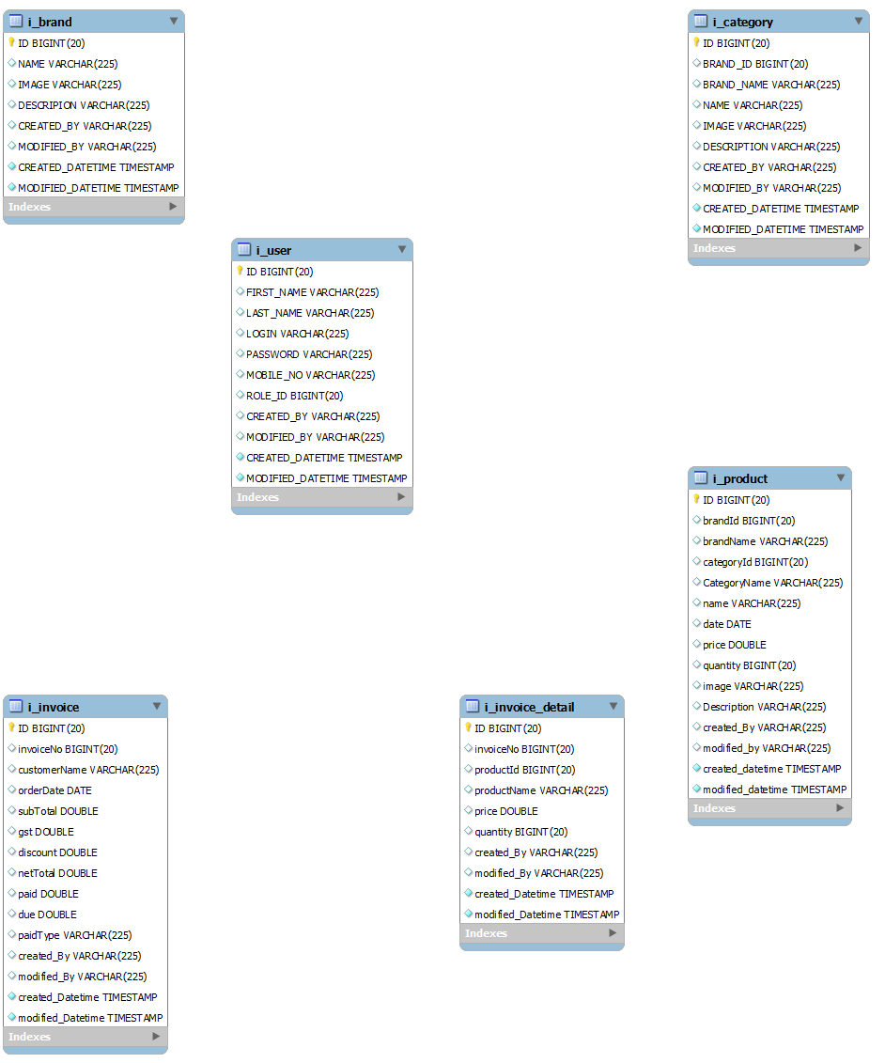

Data Flow Diagram (DFD) Level 0
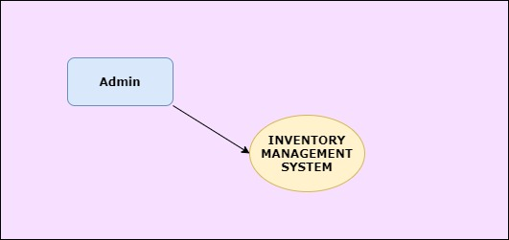

Level 1 DFD
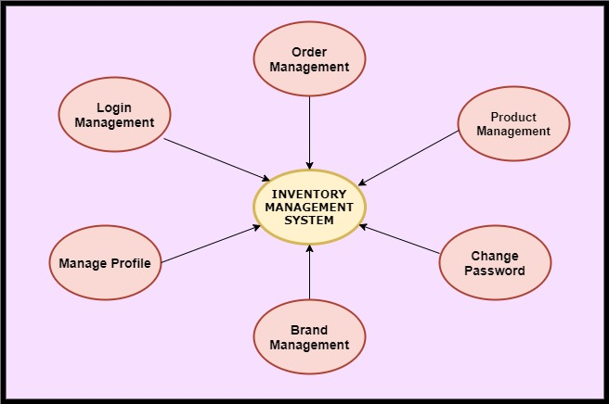

Level 2 –DFD Admin

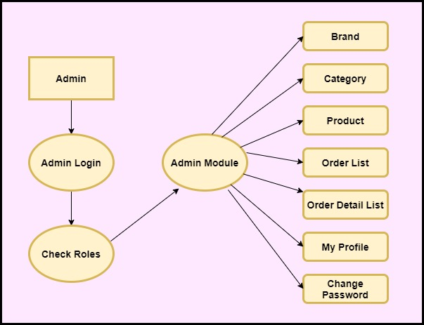

Functional DFD:
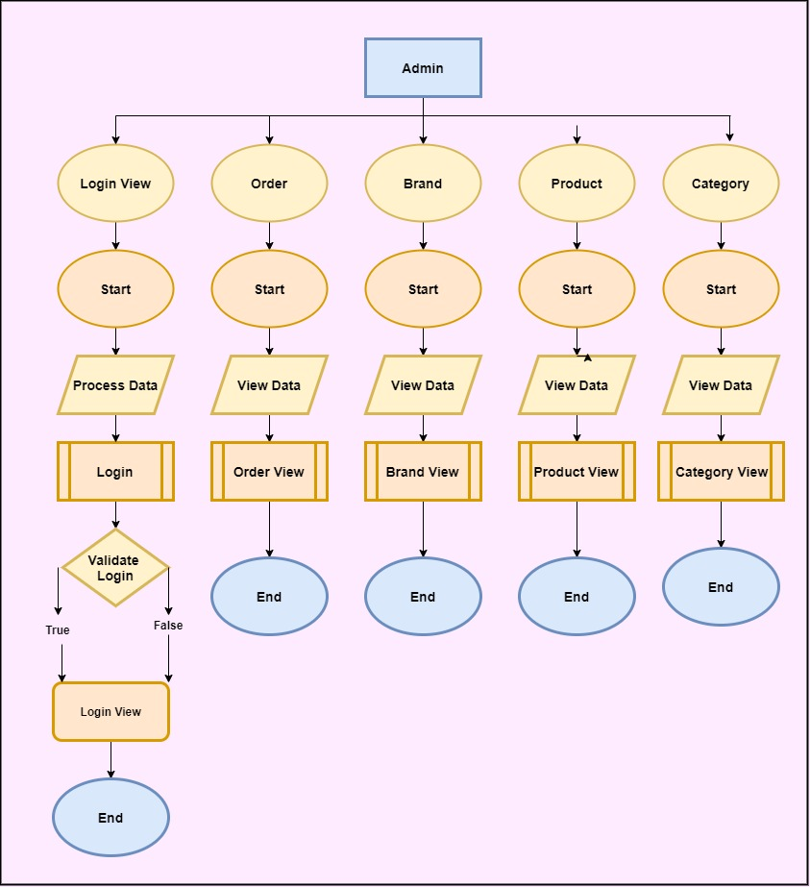

Feasibility:
This project will be developed on computer, so first check whether the technology is technically available or not. Now a day’s computer interaction with any job becomes common for any kind of job or work.

And because of increasing usage of Computer, Computer is also available with a variety of hardware. Vendors can fulfill any type of hardware requirement. The whole project is developed by some special tools or by using languages and databases, which are also available in a variety.

Preliminary investigation of a system examines the feasibility of a system that is useful to an organization. It is the first phase of system development.

The main objective of this phase is to identify the current deficiencies in the user’s environment and to determine which existing problem are going to be solve in proposed system and also which new function needs to be added in proposed system.

An important outcome of such preliminary investigation is to determine whether the system that will meet all needed requirements.

Thus, three tests are carried out on the system namely operation, technical and economical.

Any project is beneficial if and only satisfies the organization requirement. For any new system setup, it only meets to be communicated and work the other supporting system.

The new system meets all existing operations since it provides right information at a right time to the right user. A Leigh man can easily operate with the system.

Technical Feasibility examines whether the technology needed is available and if it is available then it feasible to carry out all project activities.

The technical needs of a system include:

- The facility to produce outputs in a given time.
- Ability to process large number of transactions at a particular speed.
- Giving response to users under certain conditions.

The technology needed for our system is mainly:

- Latest version of browsers.
- Any operating system.

These technologies are available which helps to carry out the system efficiently.

Economic feasibility of a system examines whether the finance is available for implementing the new system and whether the money spent is recoverable the satisfaction.

The cost involves is in designing and developing a good investment for the organization.

Thus, hardware requirements used for proposed system are very standard. Moreover, by making use of proposed system to carry out the work speedily will increase and also saves the valuable time of an organization.

In the proposed system the finance is highly required for the installation of the software’s which can also be recovered by implementing a better system.

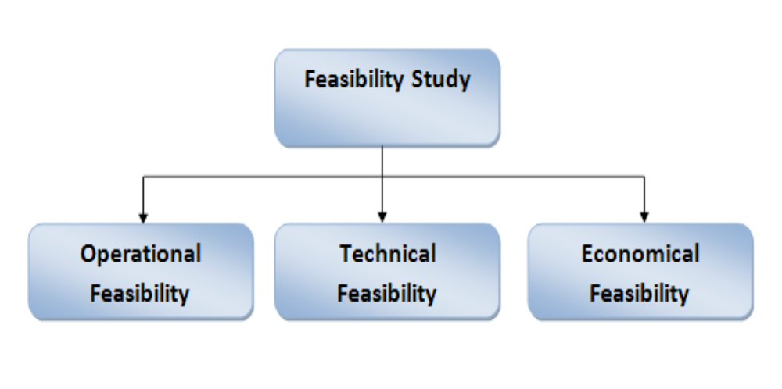

Design

Data dictionary
Data validation:
Procedures are designed to detect errors in data at a lower level of detail. Data validations have been integrated in the system in almost every area where there is a possibility for the user to commit errors. The system will not recognize invalid data.
Whenever an invalid data is keyed in, the system immediately prompts the user and the user has to again key in the data and the system will accept the data only if the data is correct. Validations have been integrated where necessary.
The system is designed to be a user friendly one. In other words, the system has been designed to communicate effectively with the user. The system has been designed with pop-up menus.

Different Types of Validation:
- Data type validation;
- Range and constraint validation;
- Code and Cross-reference validation and
- Structured validation

Coding
Implementation and Testing:
Black-Box Testing:

Black Box Testing, also known as Behavioural Testing, is a software testing method in which the internal structure/ design/ implementation of the item being tested is not known to the tester. These tests can be functional or non-functional, though usually functional.

This can be following way:

- Input interfacing
- Processing
- Output interfacing

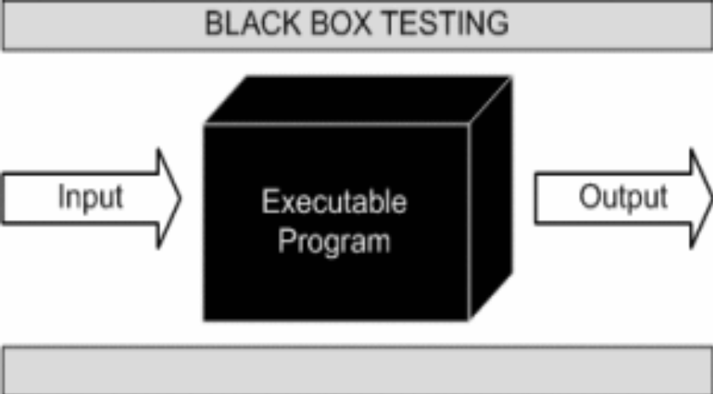

This method is named so because the software program, in the eyes of the tester, is like a black box; inside which one cannot see. This method attempts to find errors in the following categories:

- Incorrect or missing functions

- Interface errors

- Errors in data structures or external database access

- Behaviour or performance errors

- Initialization and termination errors.

White-Box Testing:

White Box Testing, also known as Clear Box Testing, Open Box Testing, Glass Box Testing, Transparent Box Testing, Code-Based Testing or Structural Testing is a software testing method in which the internal structure/ design/ implementation of the item being tested is known to the tester.

The tester chooses inputs to exercise paths through the code and determines the appropriate outputs. Programming know-how and the implementation knowledge is essential.

White box testing is testing beyond the user interface and into the nitty-gritty of a system.
This method is named so because the software program, in the eyes of the tester, is like a white/ transparent box; inside which one clearly sees.

Screen Snapshot & Source Code

Please add update SS and SC after configuration

Futures Enhancement:

- In future we can expand this project on the web.
- Software can be accessed through internet also.

Limitation:

- This application doesn’t allow you to share your order records or save it any external device.

Conclusion
This application will help the retailers, shopkeepers, grocery store owners to manage a complete record of their orders. The owner can get rid of the manual work and lot no. of paper bills. This application automates the process and provides the smooth interface to user. It covers the need of not only admin but also for users. Also, it is not a complicated system it is a simple application where anybody can access it and can work with it.
This application is designed in such a way that any future modification can be done in an easiest way.

